Session 5

# An Expedition

## Permanent Storm

Dark clouds build over the road south of Nulvac. Issues can arise from that. In one place the road is flooding and must be forded.

A Nano is using a storm generator that looks like a large balloon to feed power into a large pink crystal.

*This crystal can be used to power the castle later if the party chooses to do so.*

## Electrical Sprites (optional)

Balls of energy that flit between the trees. One touch can stop a man’s heart. It is unclear if they are hostile, or curious and unaware of their own danger

If the PC’s get their attention they will begin coming toward them.

### Electrical Sprites (LV2)

Attack for 6

If hit with conductive weapons, deal 6 damage.

## Shadows and Mist

In the fog of night shadows appear, humanoid but amorphous. They stand in the tree line watching. They move strangely but are not threatening. They will eventually begin echoing words back, and then attempt to speak.

They will mainly hit words like “Danger” and “Lost” and “Please”

The people of Batos have a Nano who has been studying the shadows. He has seen another kind of shadow in the mist that seems to be a huge creature. He’s been working on a machine to allow people to cross into the plane these beings are on but needs many components. (Many of these can be found in the temple deep in the forest, he may also need info from someone in the dream sallow depending on how things are going).

## Night Encounters

### Band of Culova (14+)

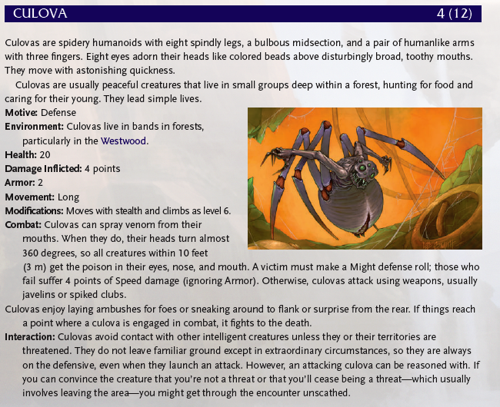

### Nibovian Companion (on a 17+)

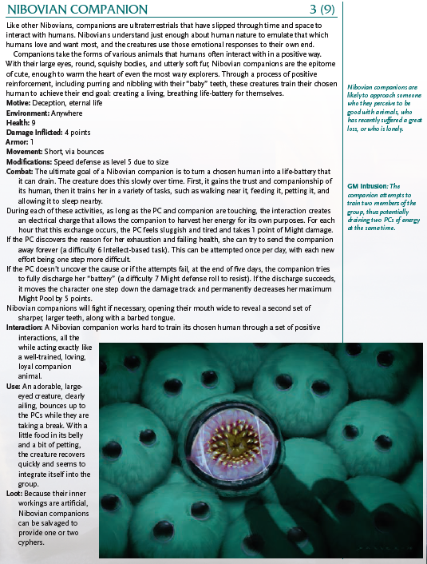

## Cultists

There are cultists in these woods wearing black and green robes. They are a radical sect of Hestans.

They have a town called Zeela that exists in the shadow of the great step pyramid.

Johann may be able to convince them that he wants to ascend which will allow access to the labarynth.

## Dream Sallow

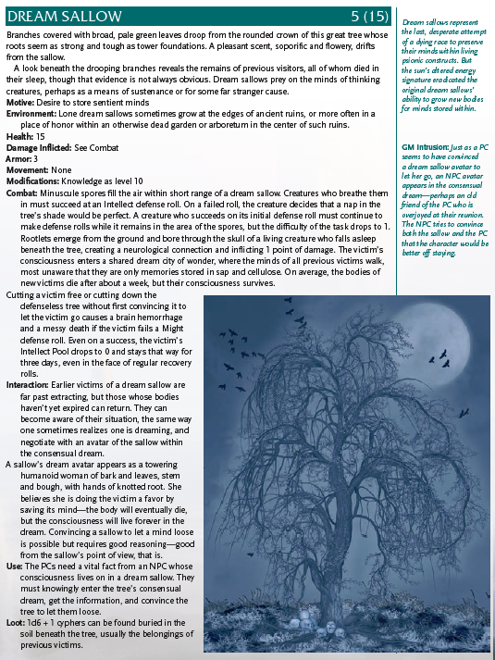

## Inside the Dream

# Batos

A town in the woods created by Culova

# Back in Town

# Crafting

## Lightning Staff

* Pink Charge Crystal
* 20 shins
* 3 XP
* A conductive rod of some kind
* An ark capacitor

*Range: Short*

*Damage: 4 (electric)*